**Android Architecture (Jetpack)**

**1**

* Breif Overview of Architecture Component.
* Problem with existing system.
* What is Jetpack?

Androd Architecture Component.

* Android has component-based architecture –where you use different components like Activity,Fragments,Service etc.
* It is Android that manage these Components for you.
* Till now ,we have been writing code in our android activities or fragment for all purpose –wheather it is data fetching or storing data in SQLite.
* This is where the Problems lie.

**Pattern**

* MVC
* MVP
* MVVM

What you want this architecture component.

* Separation of concerns.
* Data Driven Applications.

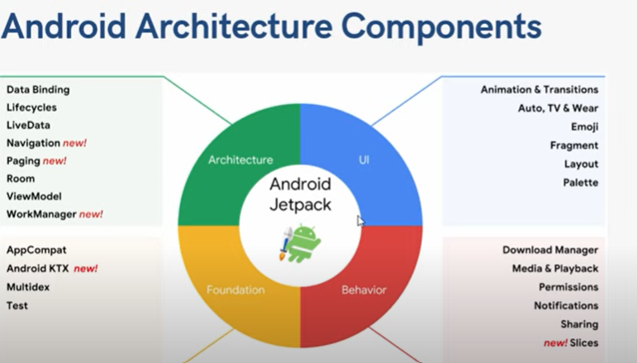

**Summaries**

* Collection of library that helps build robust,testable and maintainable android Apps.
* Less BoilerPlate code – Room,Navigation Components, Paging etc.
* High Quality,Production Ready Apps.

**2**

**Component Likes that.**

* Data Binding.
* ViewModel
* LiveData
* Room Database
* Navigation Component
* Work Manager
* Paging

**Life Cycle Aware Component**

* Most of the code written inside Activity LifeCycle Methods – onCreate,onResume,onPause etc.Due to this, Acitvity has multiple responsibilities.
* But there are scenarious where we want to take actions based on the activity lifecycle.
* For e.g.
* Access the User’s Location
* Playing Video.
* Downloading Images.
* **Components Name**
* LifeCycle Owner
* LifeCycle Observer

